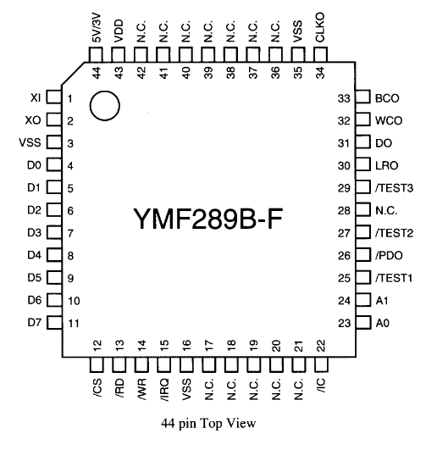
Parts that need soldered:

U3 → YMF289B. Oriented with text right-side-up

https://map.grauw.nl/resources/sound/yamaha_ymf289b.pdf

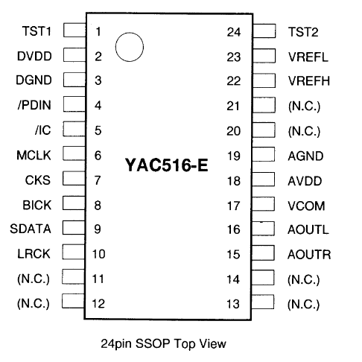

U7 → YAC516. Oriented with pin 1 in top left corner

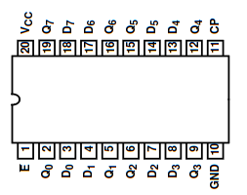

U5 → CD74HC377PWR. Oriented with pin 1 in lower left corner.

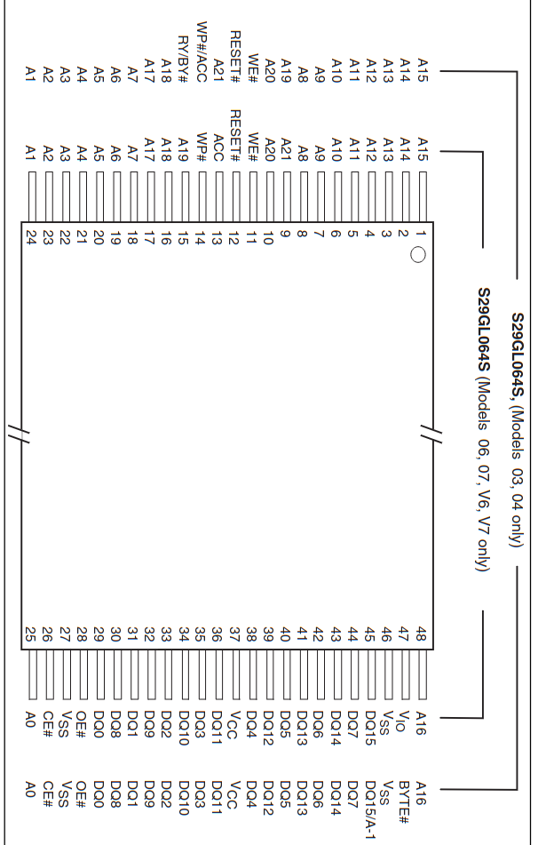
U11 → S29GL064S70TFI040. Oriented with Pin 1 in top right corner.

Y1 – HCM4933868800ABJT. I don’t think crystals are polarized but the pin on top is pin 1.

From: Nick Faro

6781 E. Manor Drive
Terre Haute, IN
47802

